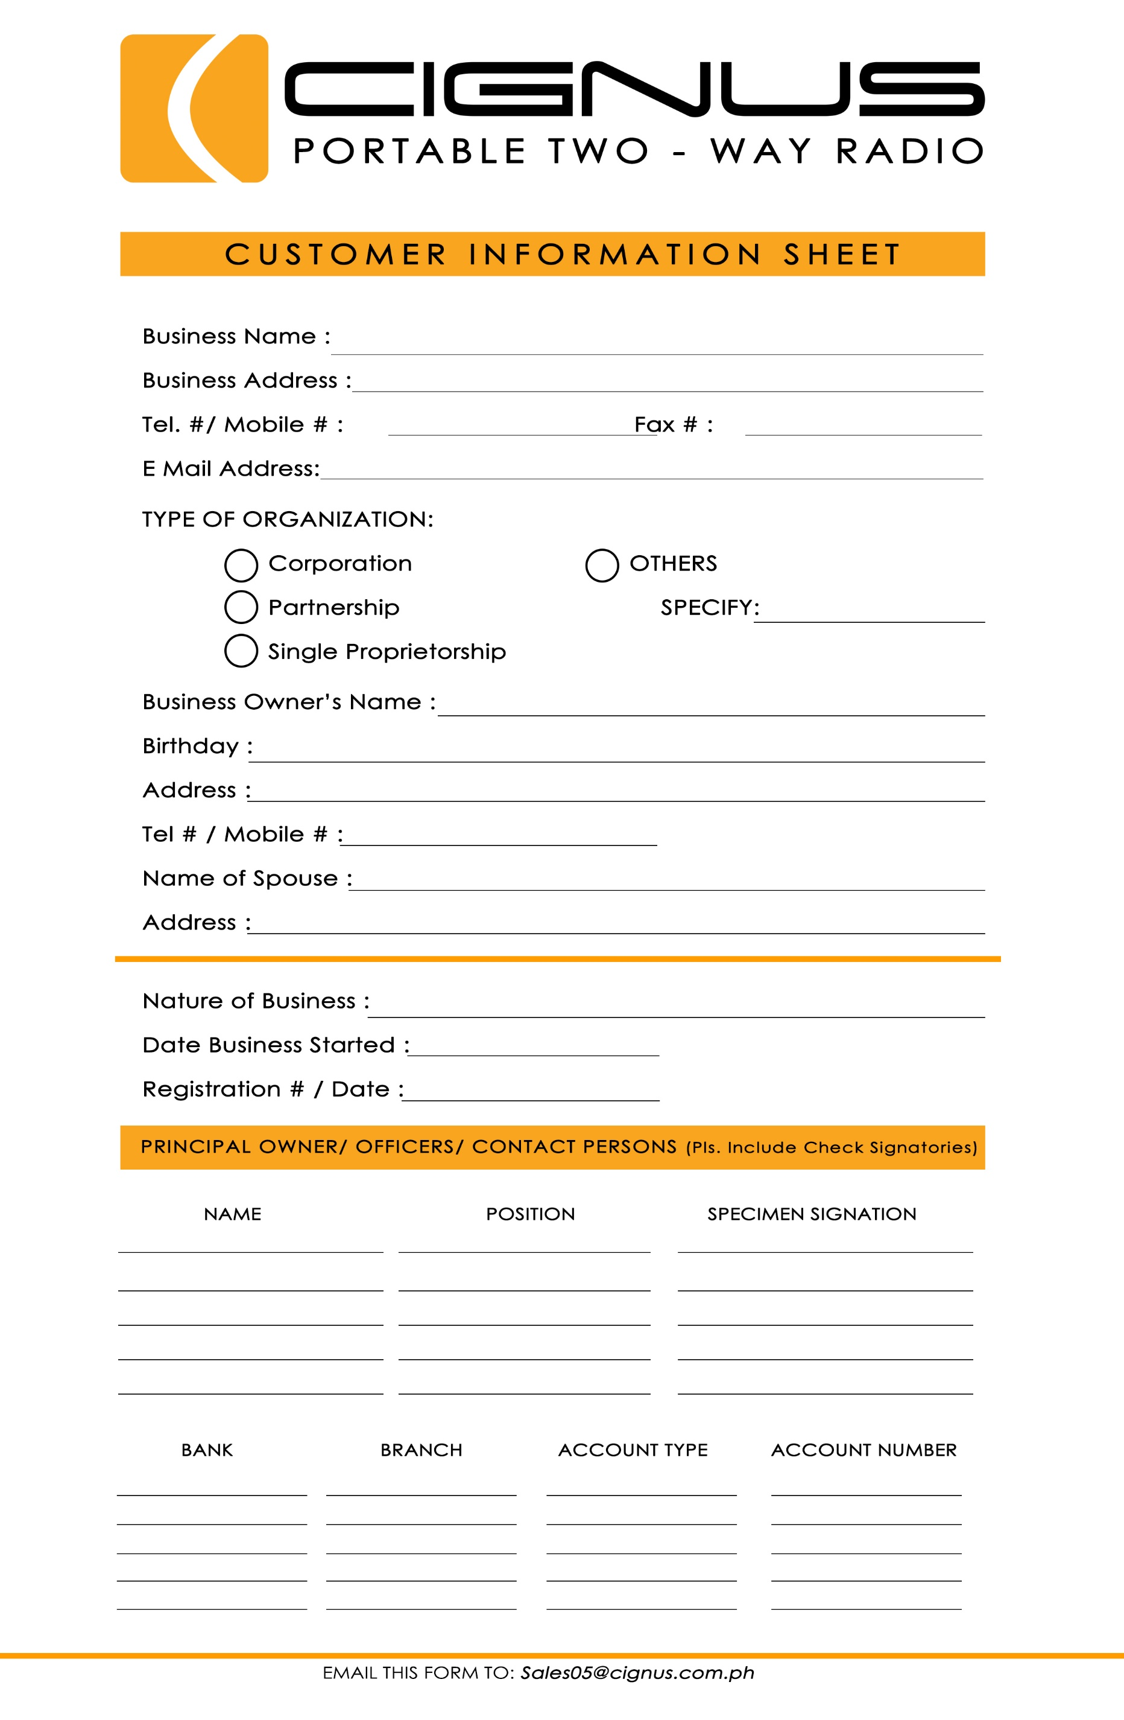

EDIT HERE

EDIT HERE

EDIT HERE

EDIT HERE

EDIT HERE

EDIT HERE

EDIT HERE

EDIT HERE

EDIT HERE

EDIT HERE

EDIT HERE

EDIT HERE

EDIT HERE

EDIT HERE

EDIT HERE

EDIT HERE

EDIT HERE

EDIT HERE

EDIT HERE

EDIT HERE

EDIT HERE

EDIT HERE

EDIT HERE

EDIT HERE

EDIT HERE

EDIT HERE

EDIT HERE

EDIT HERE

EDIT HERE

EDIT HERE

EDIT HERE

EDIT HERE

EDIT HERE

EDIT HERE

EDIT HERE

EDIT HERE

EDIT HERE

EDIT HERE

EDIT HERE

EDIT HERE

EDIT HERE

EDIT HERE

EDIT HERE

EDIT HERE

EDIT HERE

EDIT HERE

EDIT HERE

EDIT HERE

EDIT HERE